**Hypothesis testing**

**Level of confidence (c)** 🡪 tells us how sure we are , we have made the right thing.  
Eg:99% confidence, we decided to reject the null hypothesis. Then it is concluded it is 99% sure with certainty that rejecting null hypothesis was correct.  
Eg : If 50% of confidence, then we decided to reject the null hypothesis, then who is going to believe this???   
If the level of confidence is higher than 90%, then only believing the null/alternate hypothesis can be concluded.

**Level of significance** ( ) 🡪 1-level of confidence.  
if Level of confidence 🡪 95%, then c=0.95  
level of significance 🡪 1 – c 🡪 1 – 0.95 🡪 0.05



**Level of significance and level of confidence is concluding that How sure are we making the right decision or not all.**

**P-value method :**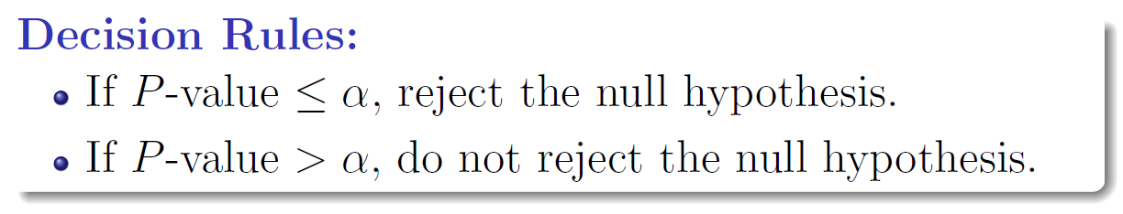

**Standard Normal Distribution Table**

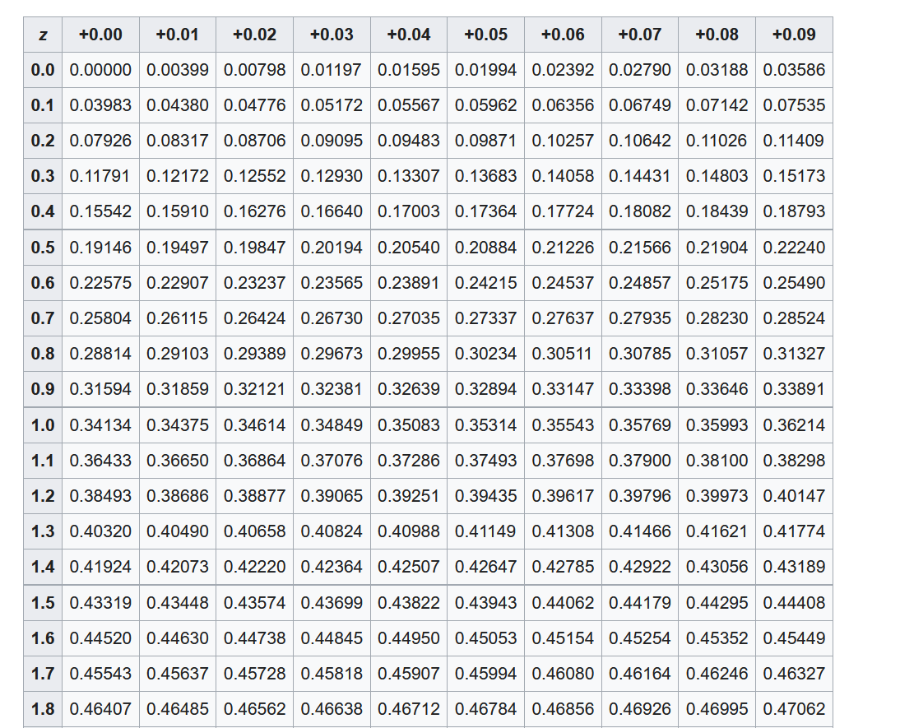 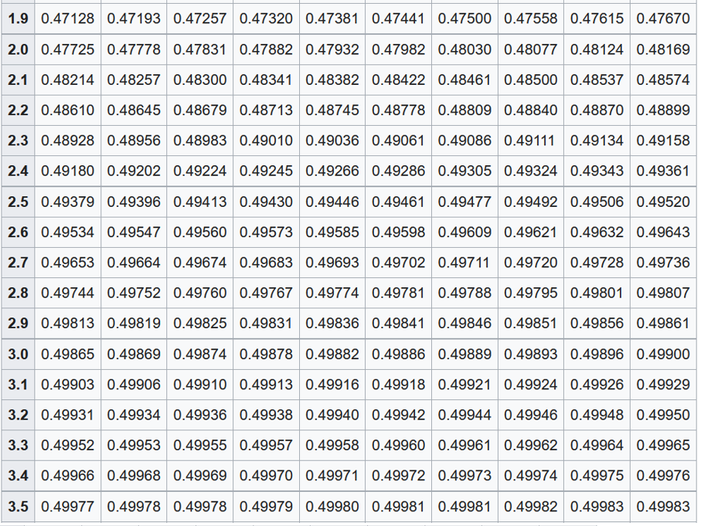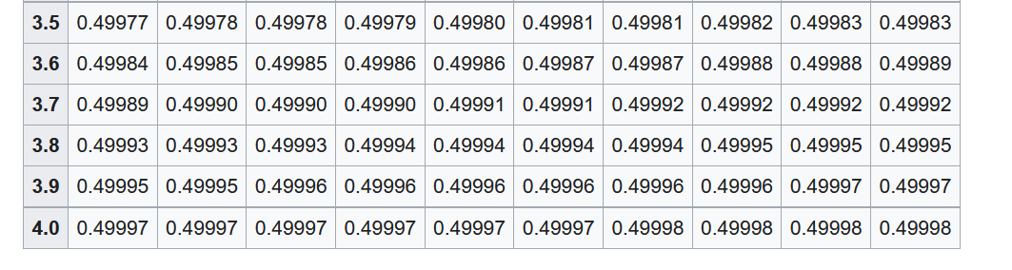

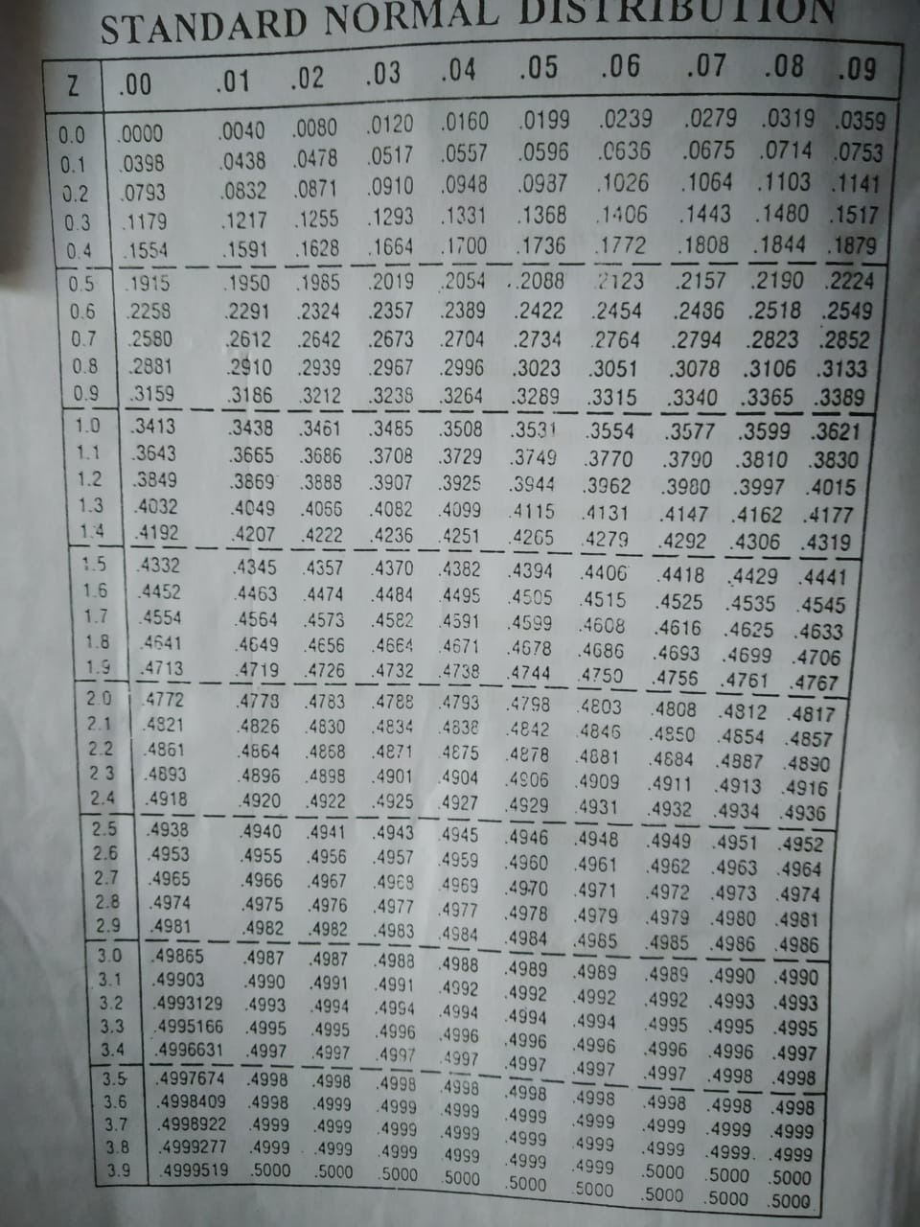



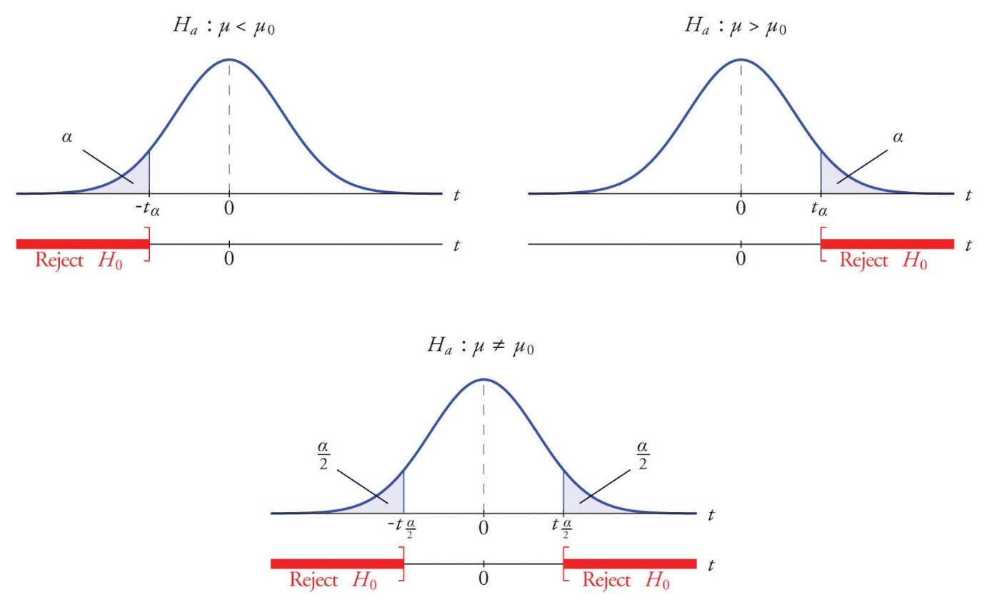

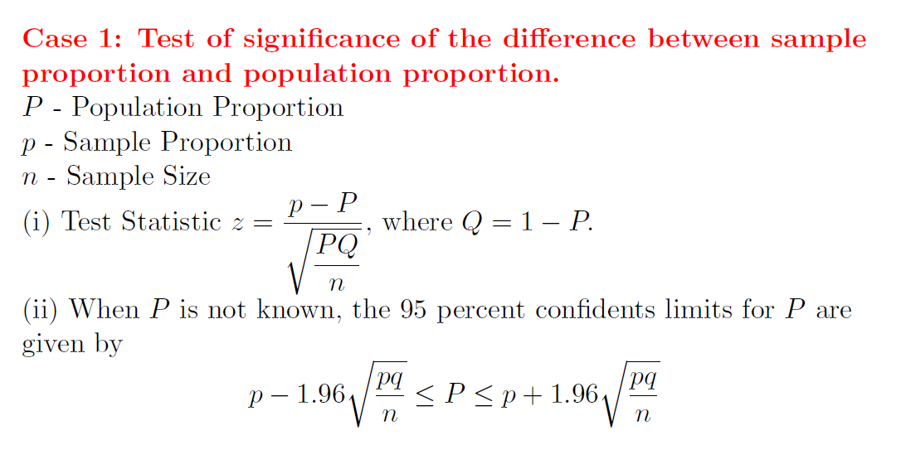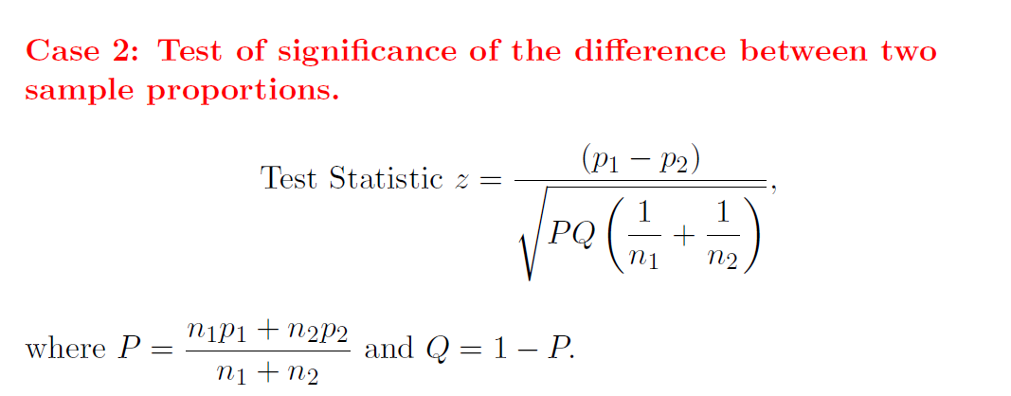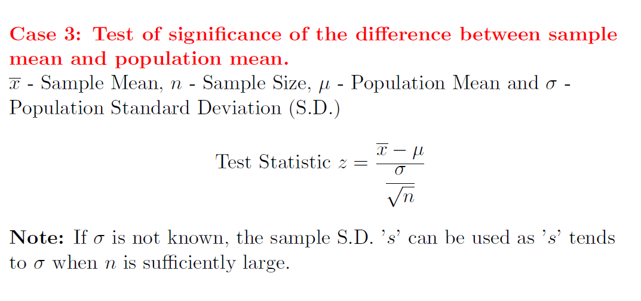

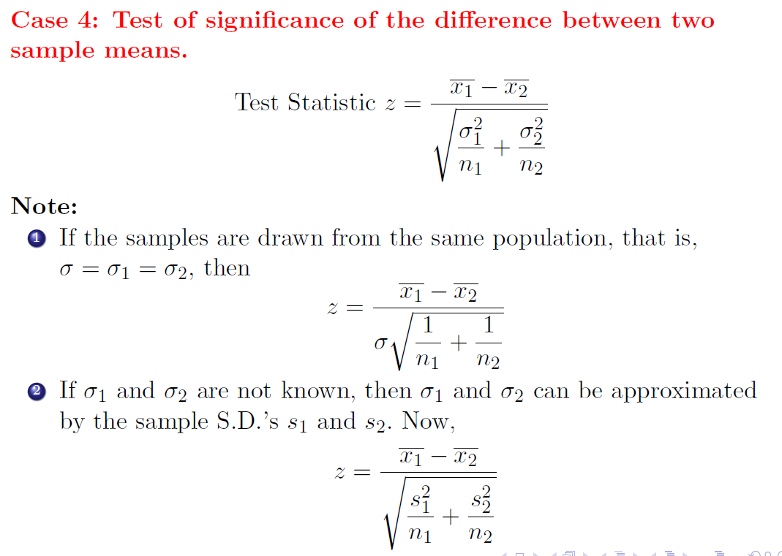

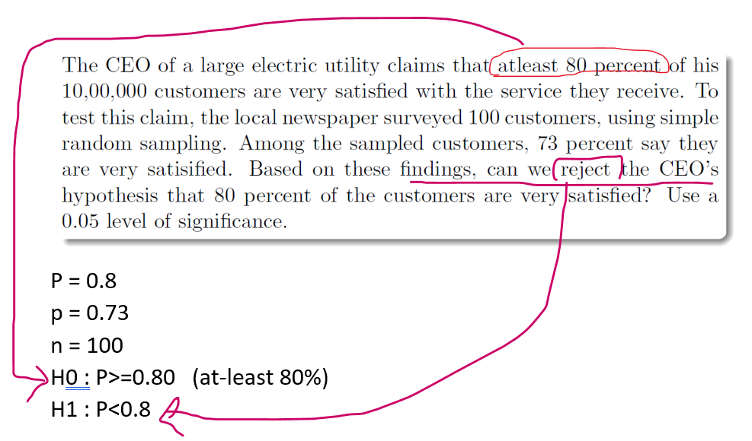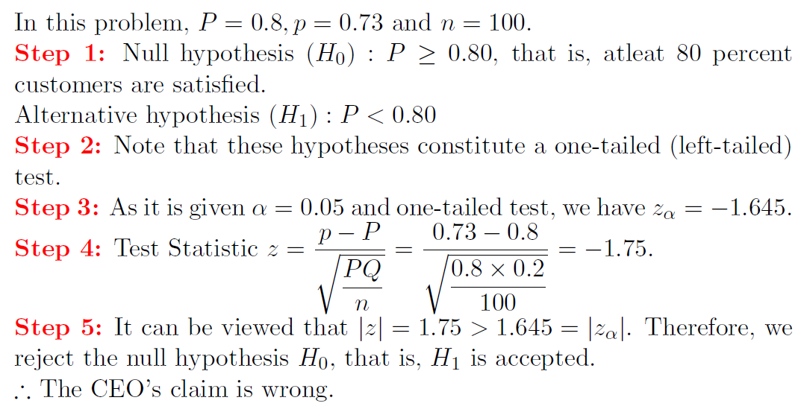



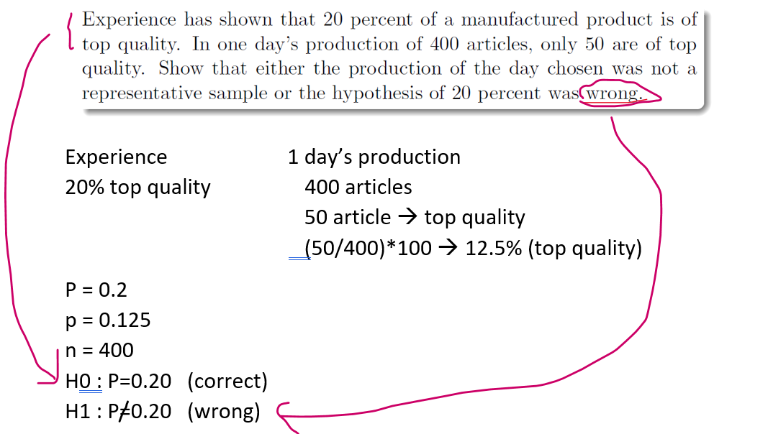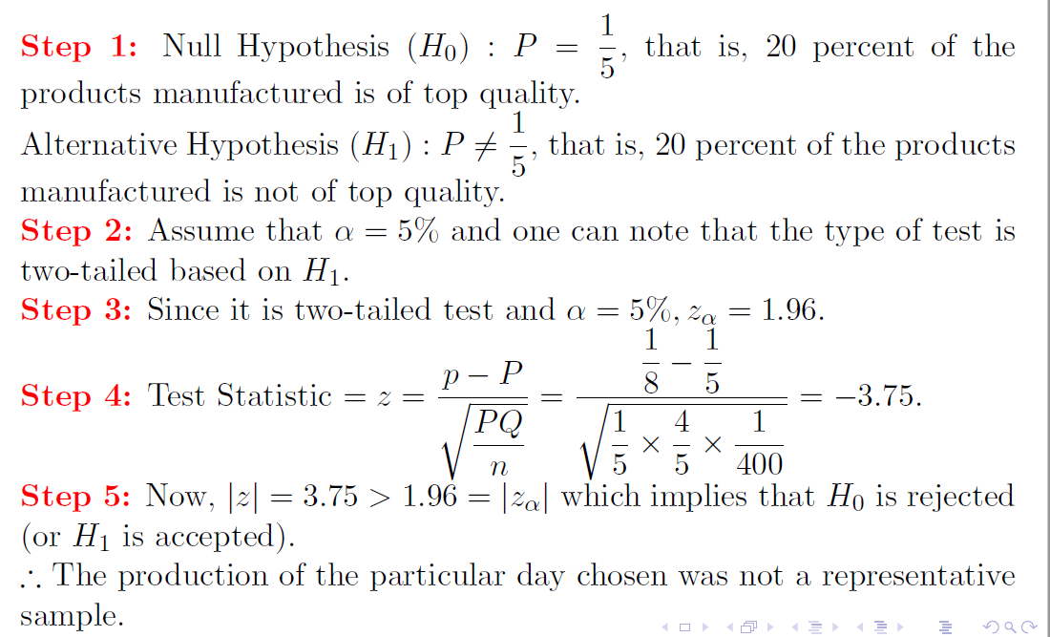



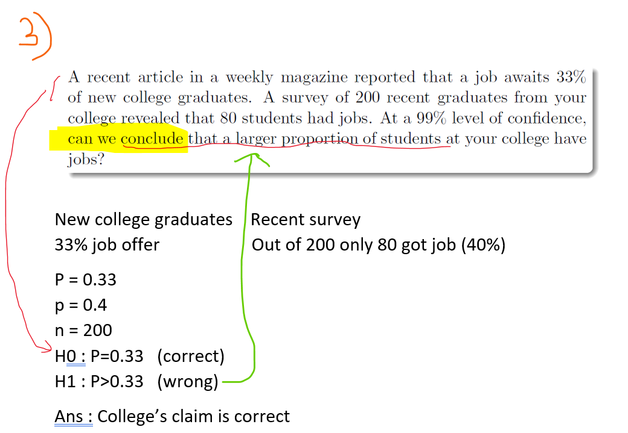



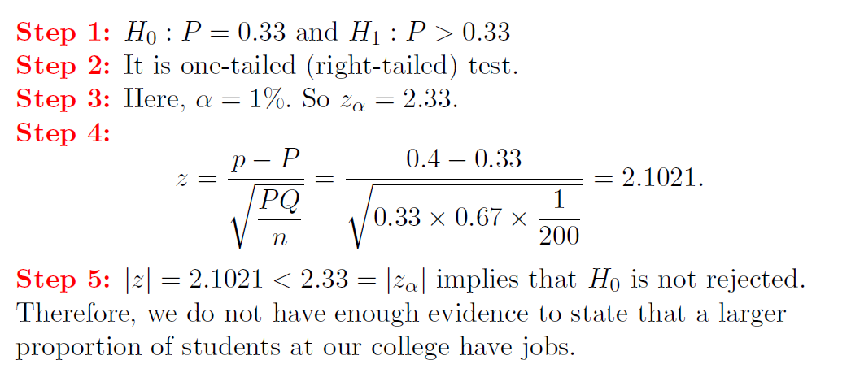

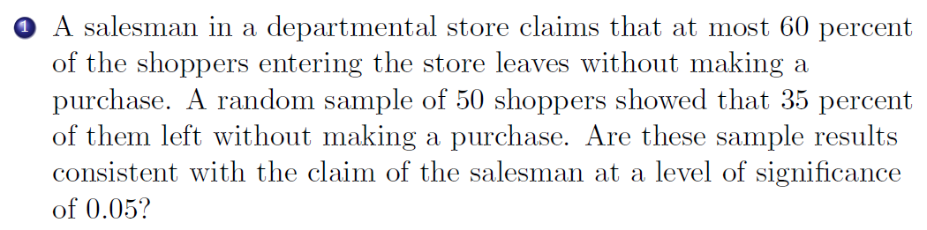

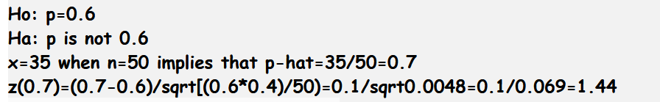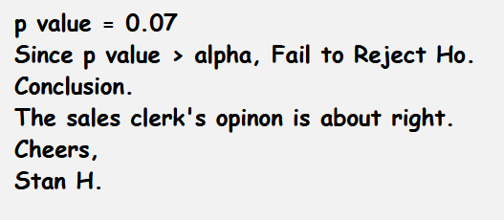

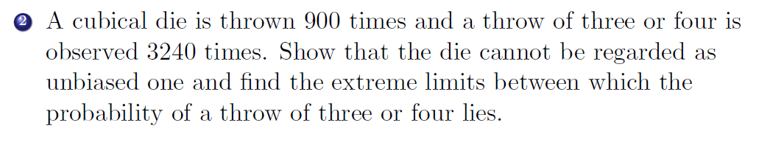

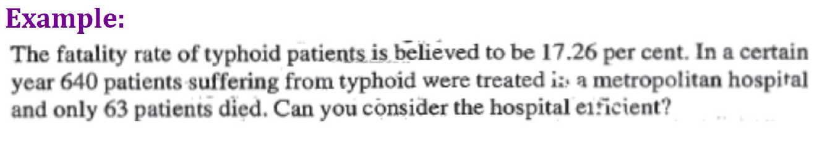­­

General Metropolitan Hospital   
Death 🡪 17.26% 640 patients   
 63 died (63/640)*100 🡪 9.8%

P = 0.1726  
p = 0.098  
n = 640  
H0 : P=0.1726 (believed)  
H1 : P>p (Efficient hospital 🡪 When the death rate of the hospital is low )

Ans : Hospital is efficient

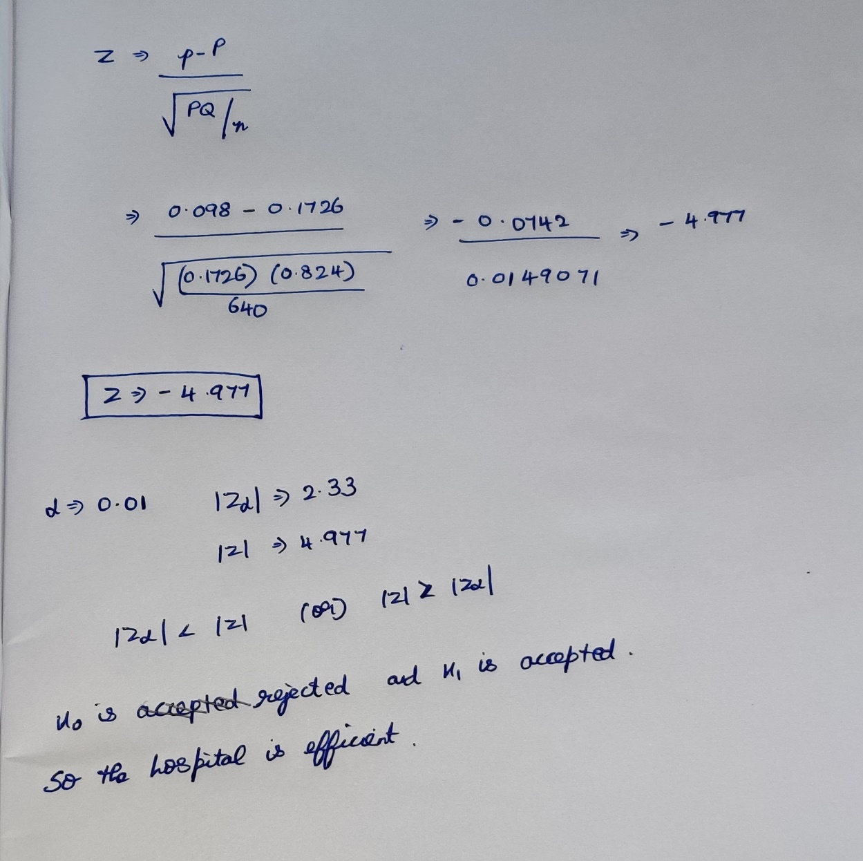

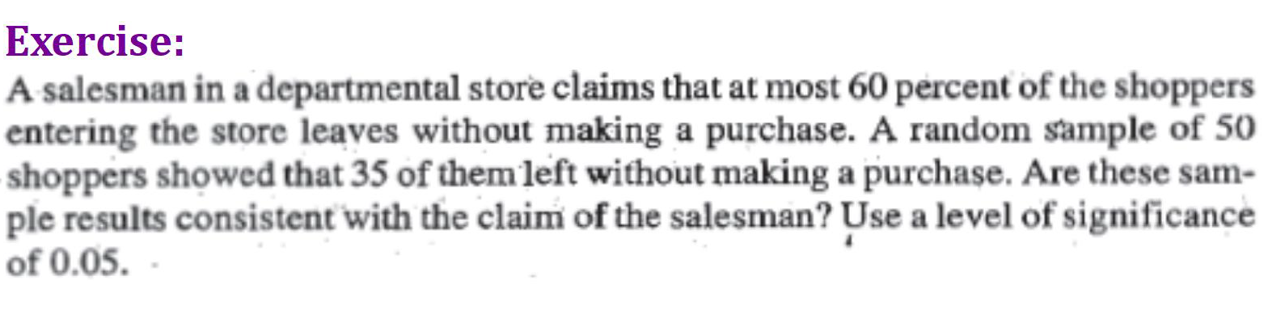



Salesman claims Random Sample   
Atmost 60% (35/50)*100 🡪 70%



P = 0.6  
p = 0.7  
n = 50  
H0 : P=0.6 (atmost) **[p=P]**H1 : P>0.6 (without making a purchase) **[p>P]**



Ans : Sales clerk opinion is right

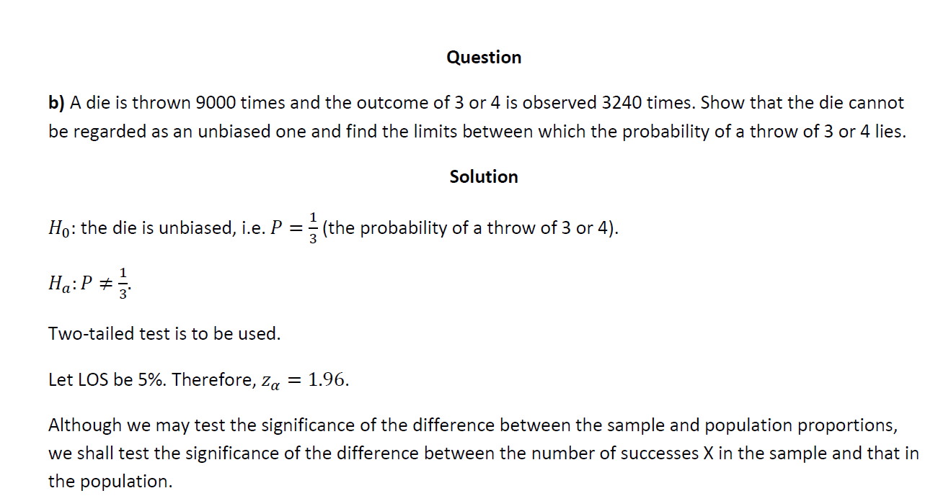  
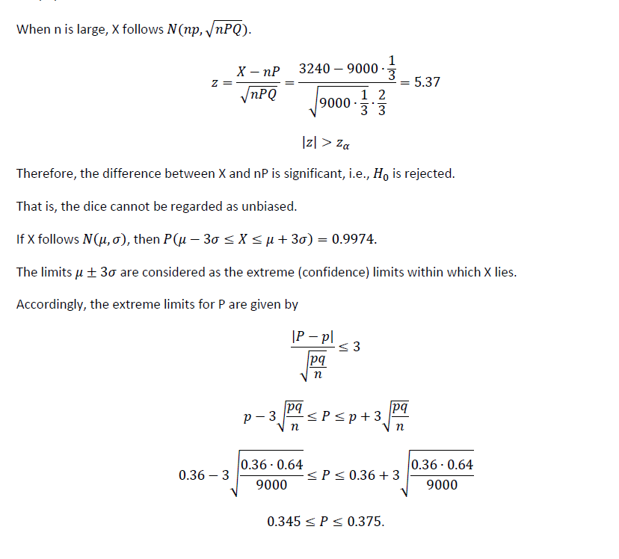

**Case-2 (Difference of proportions)**



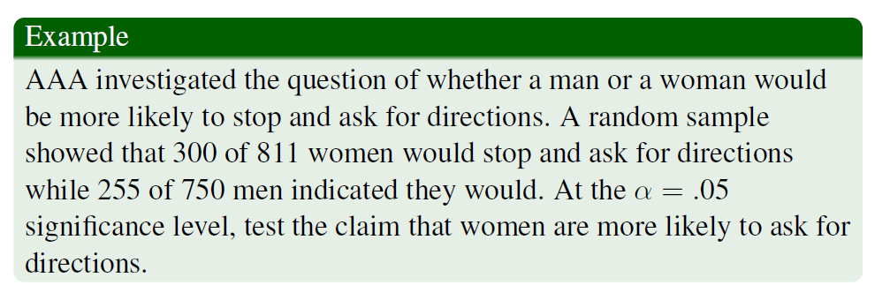

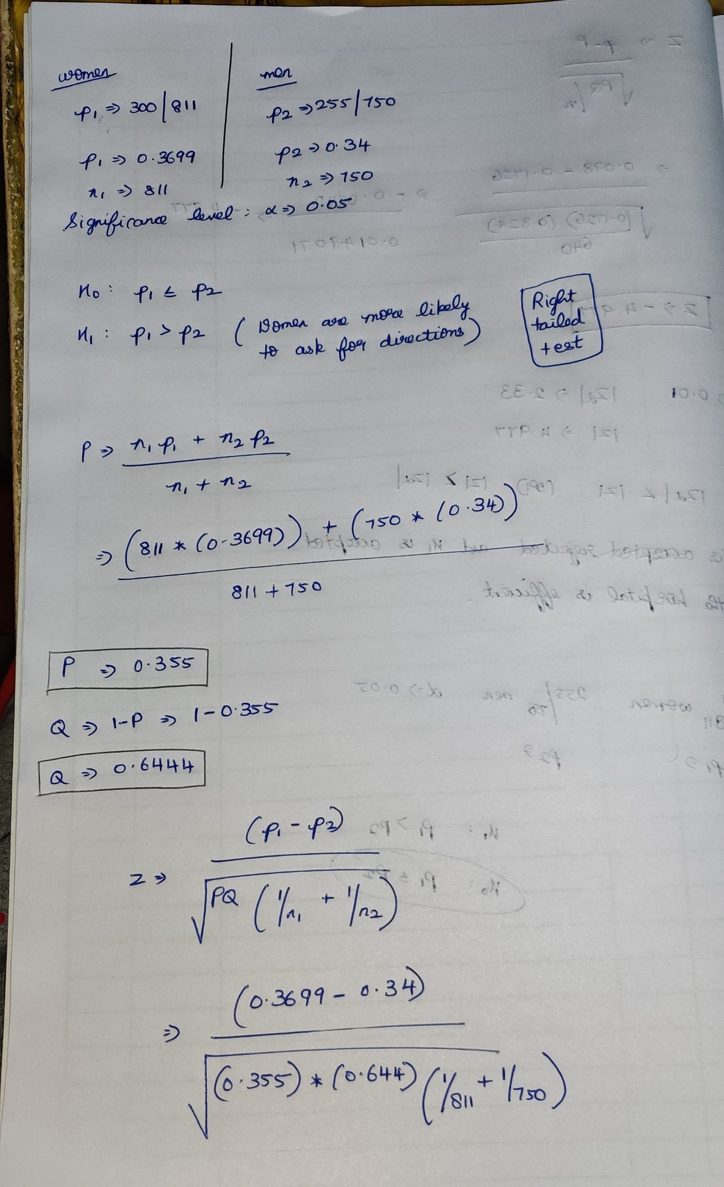

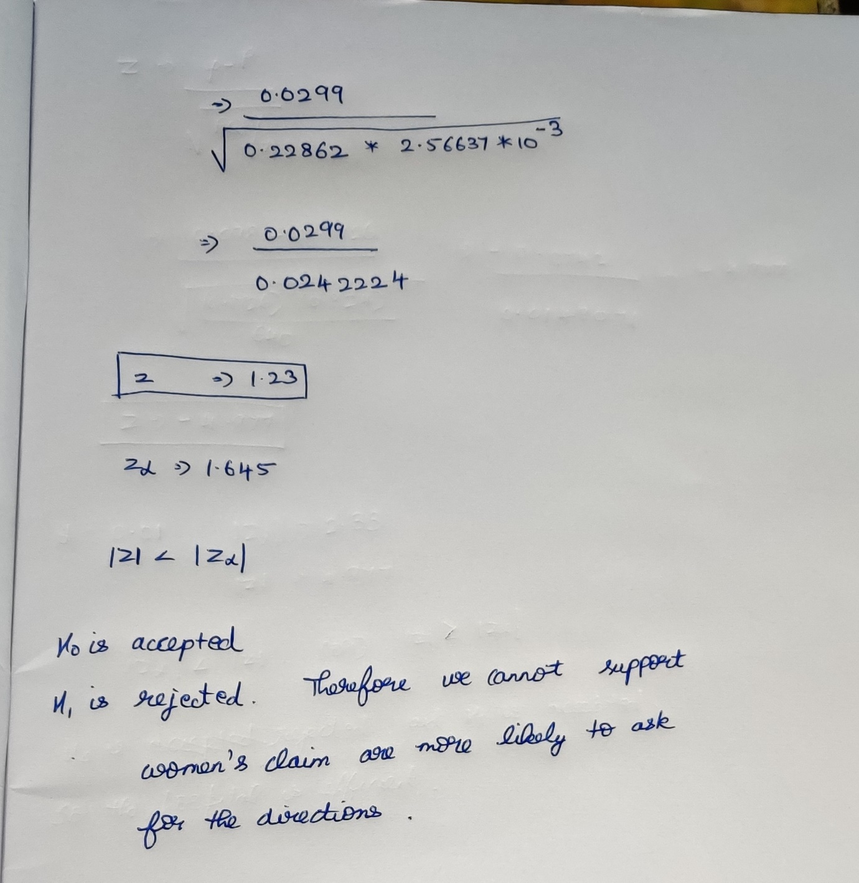

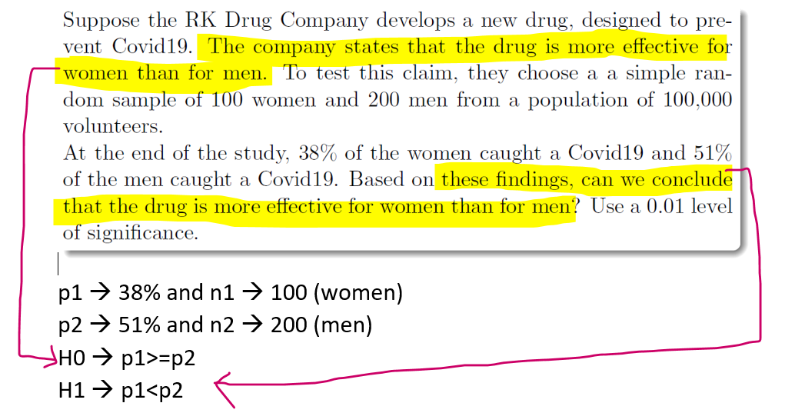

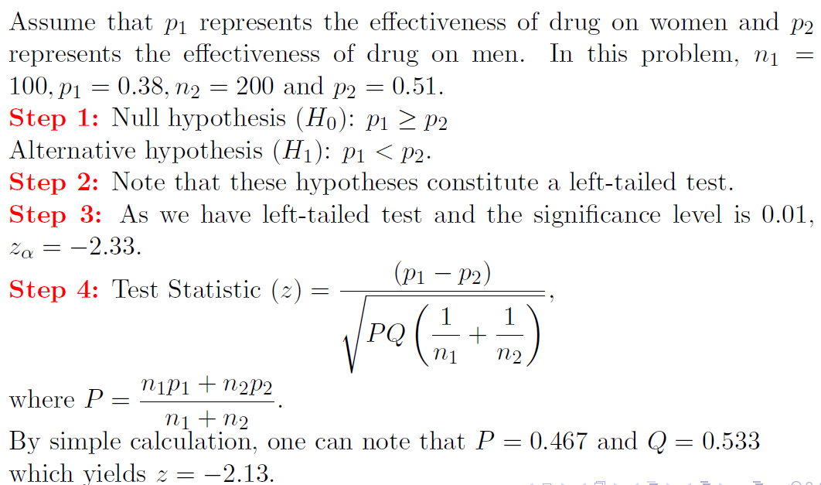

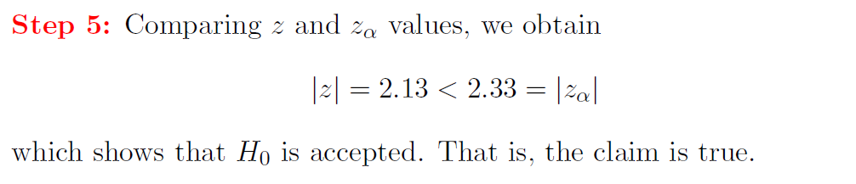

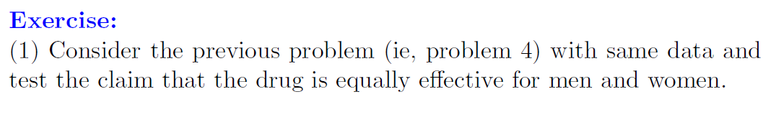

Doubt

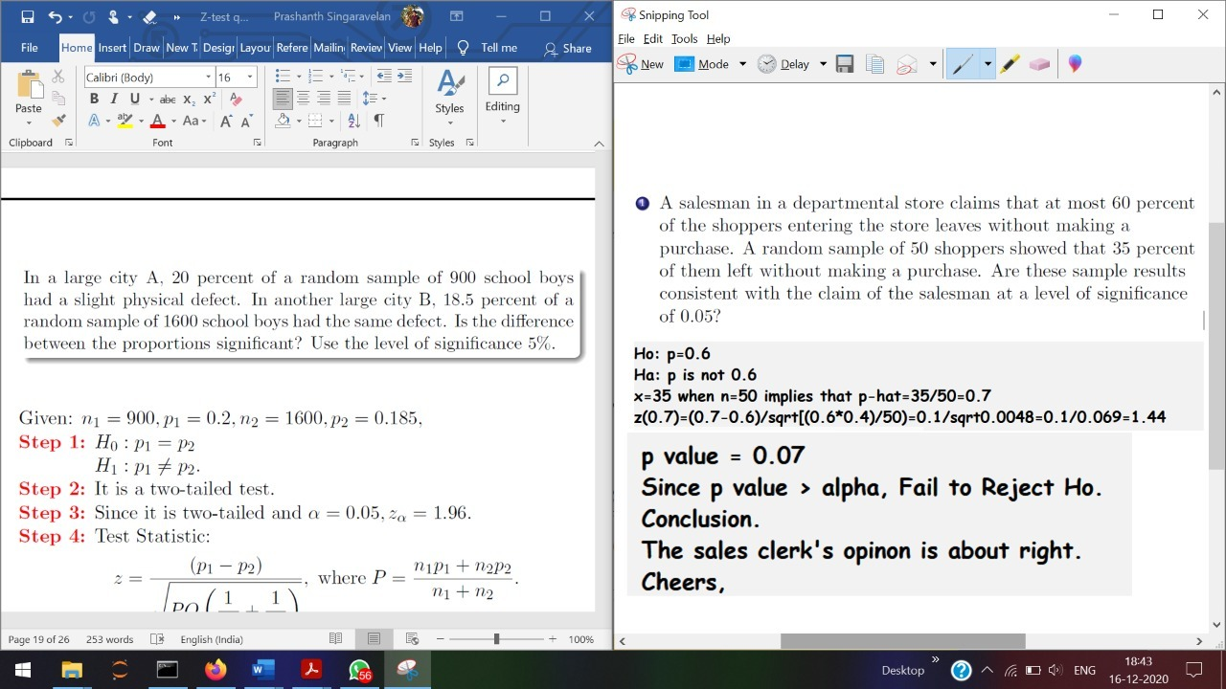

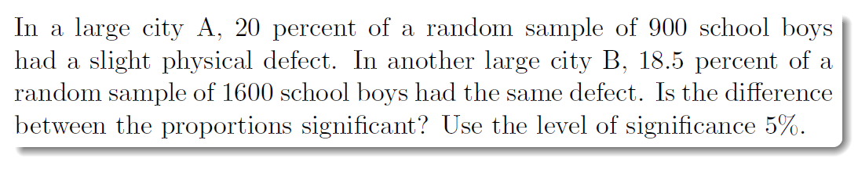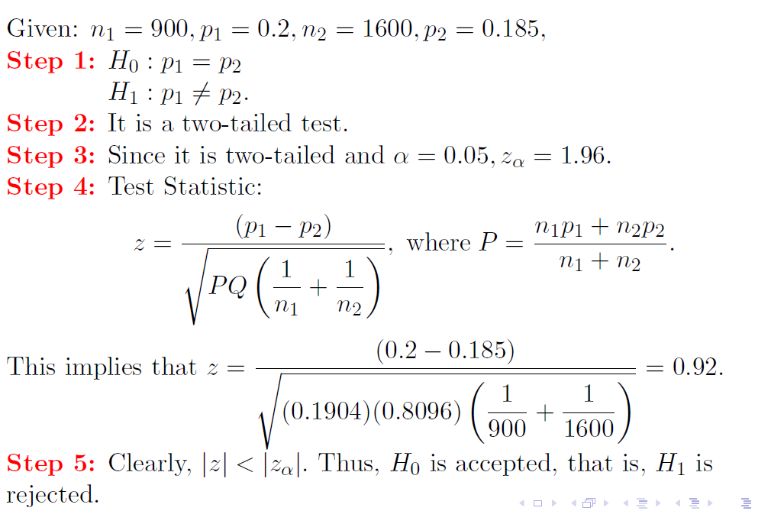

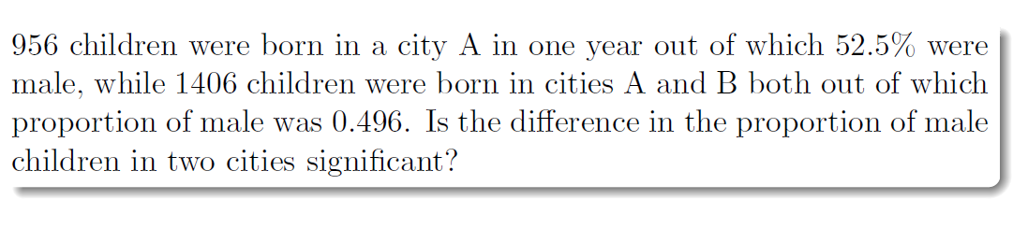

Sample-1 🡪 City A  
Sample-2 🡪 City B  
Population 🡪 Sample-1 + Sample-2

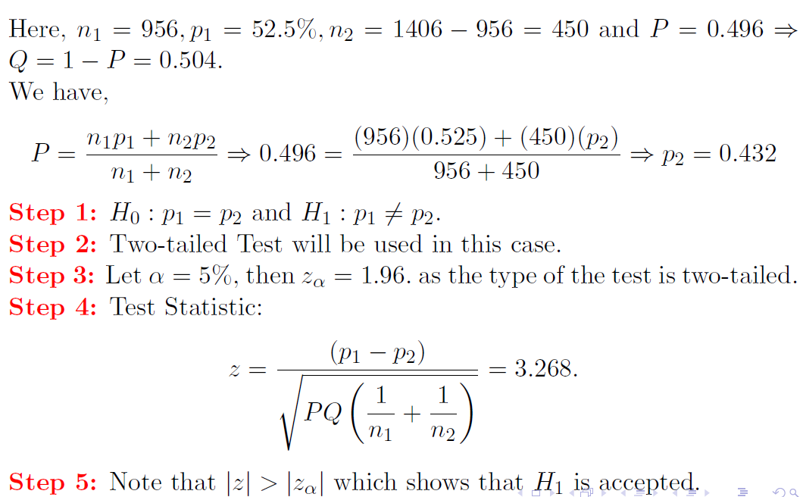

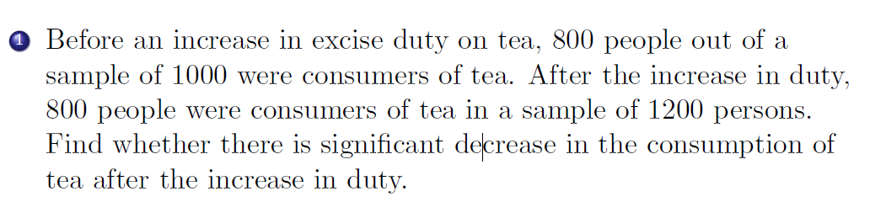

n1=1000 n2=1200  
p1 = 800/1000 🡪 0.8 p2=800/1200 🡪 0.667

**H0 🡪 p1=p2** (there is no significance decrease in the consumption of tea before and after increase in the duty)  
**H1 🡪 p1>p2** (there is significant decrease in the consumption of tea after the increase in duty)  
(right tailed test)

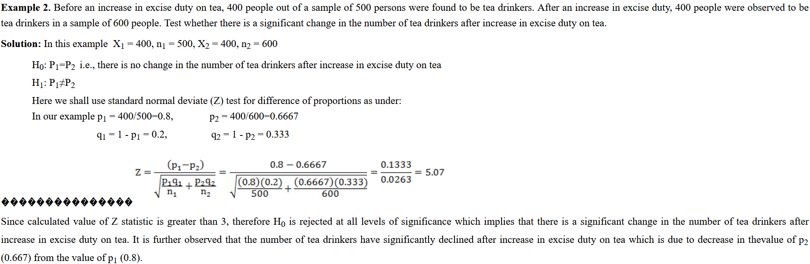

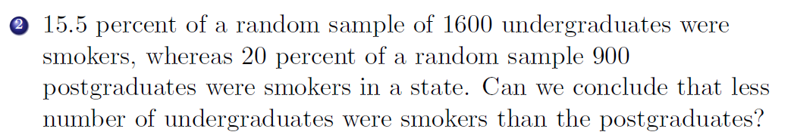p1=0.155 p2=0.2  
n1=1600 n2=900

H0 🡪 p1=p2  
H1 🡪 p1<p2

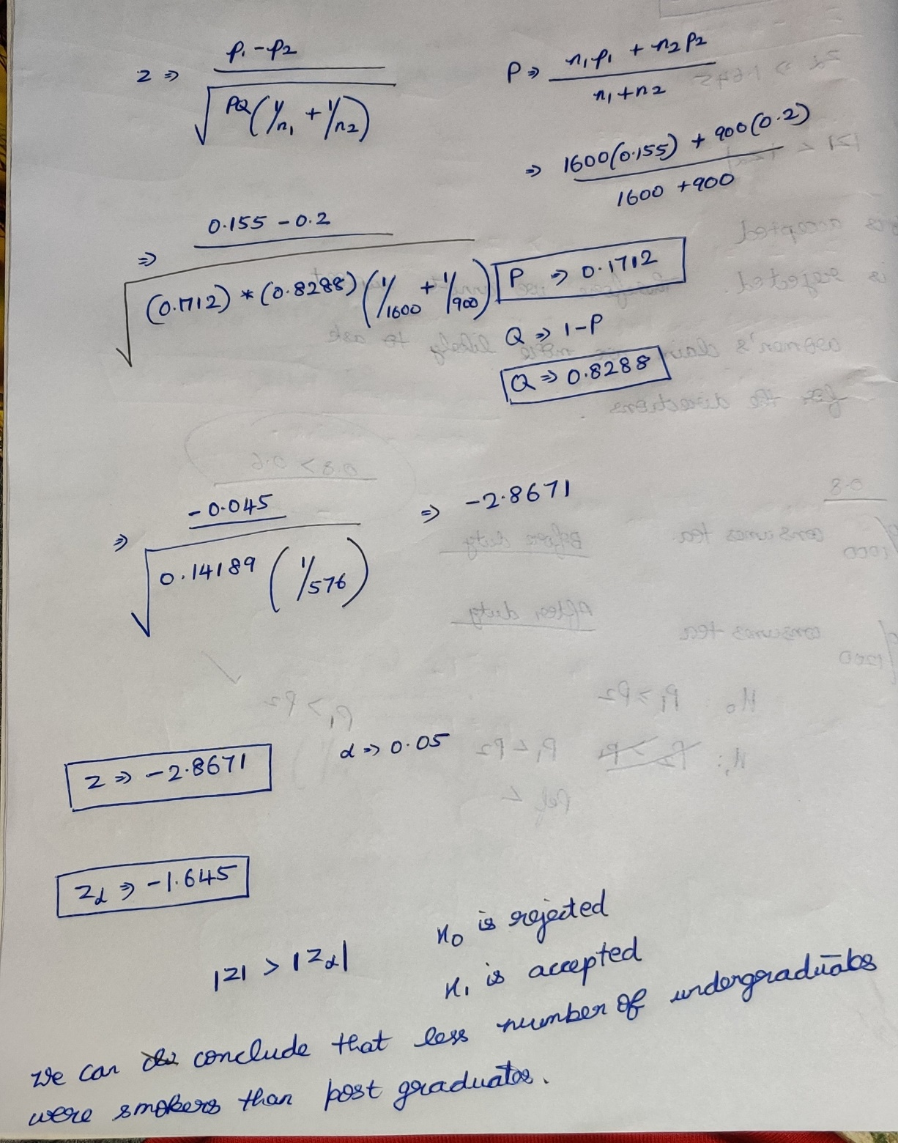

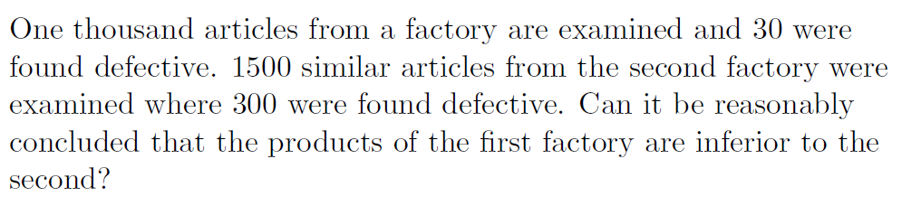

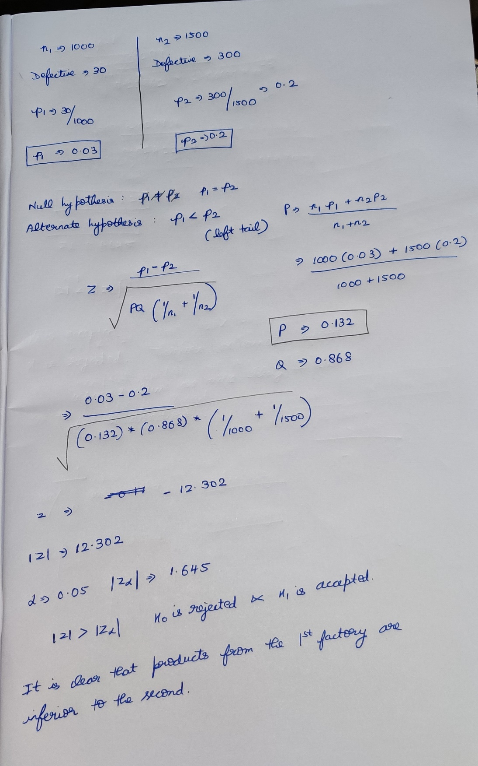

**Case-3(Test of significance of the difference between the sample and population mean)**

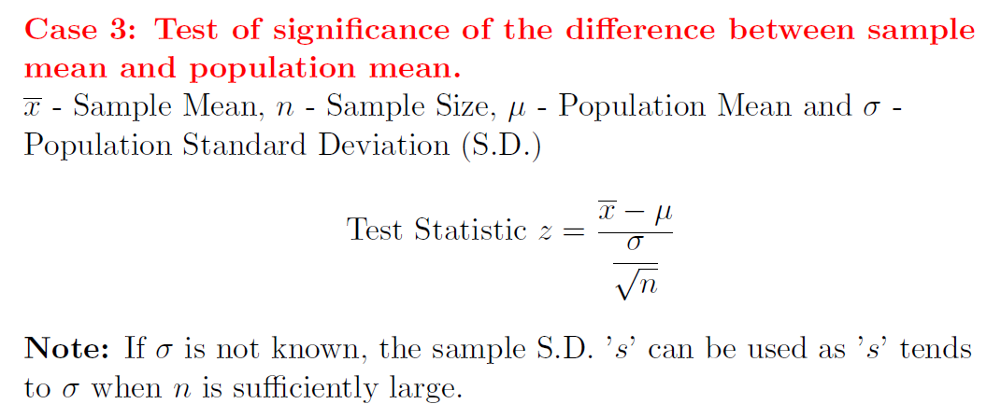  
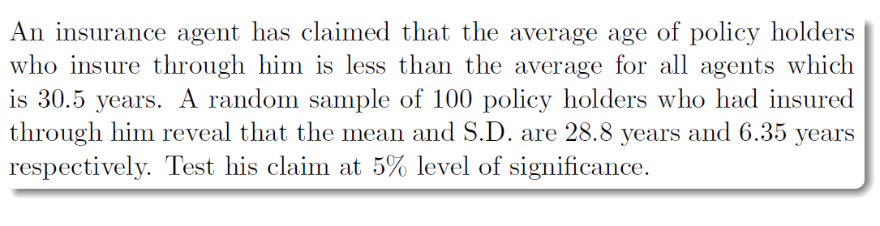  
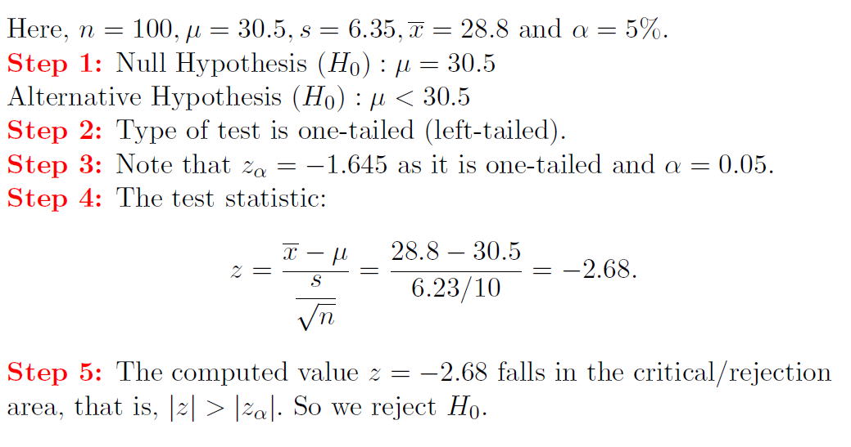



The same question without sample mean standard deviation

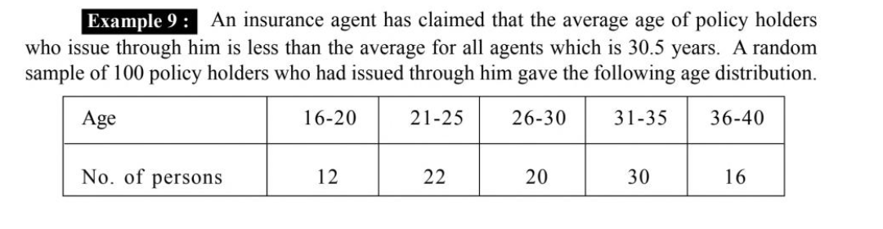

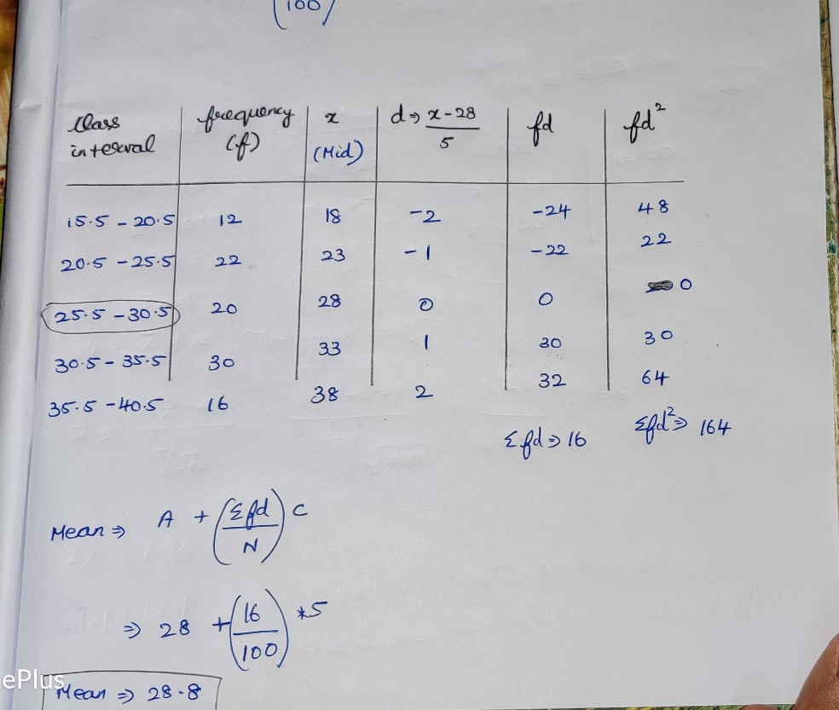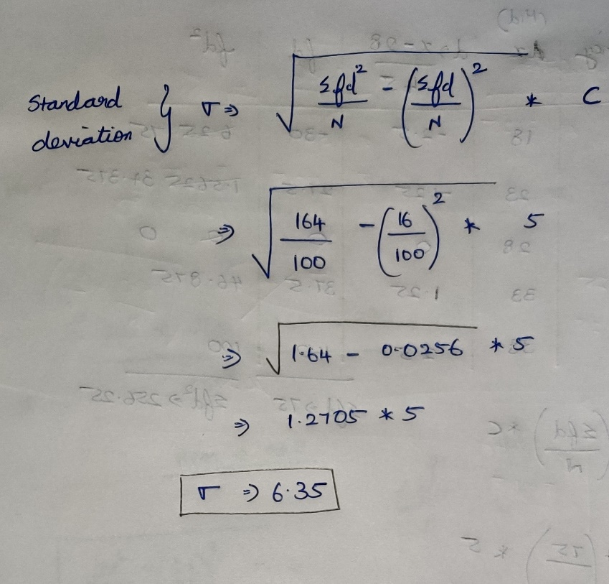

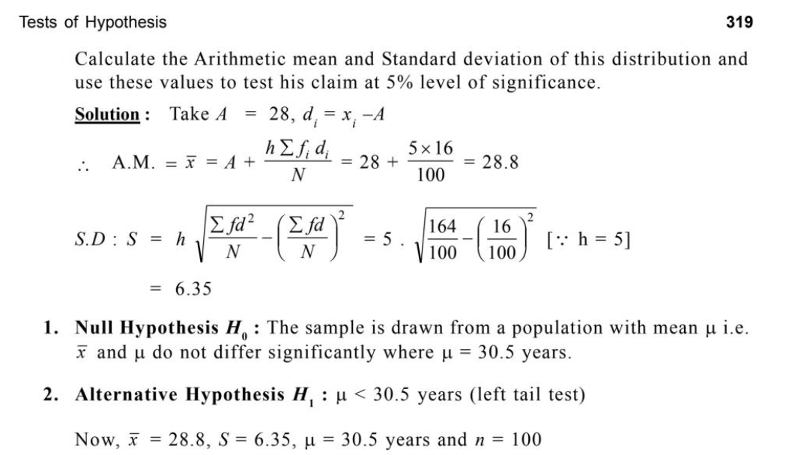  
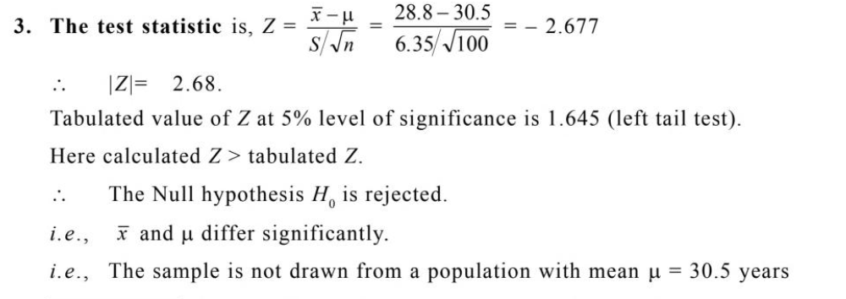

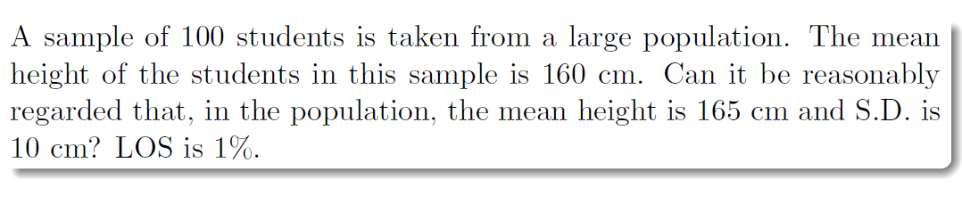  
From the sample’s view it is asked that in population also, is the mean height=165. [Comparing the sample mean and population mean]



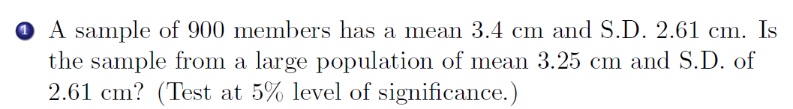  
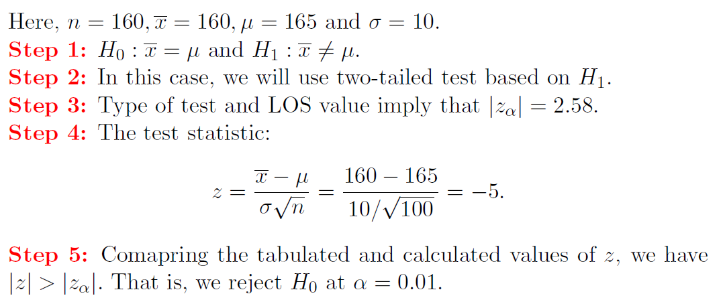



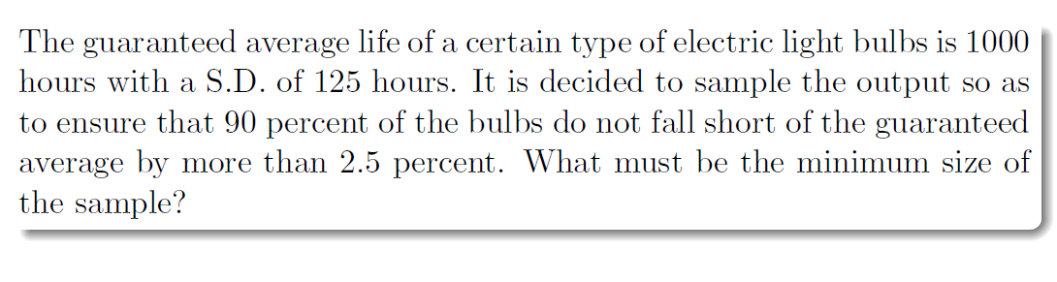  
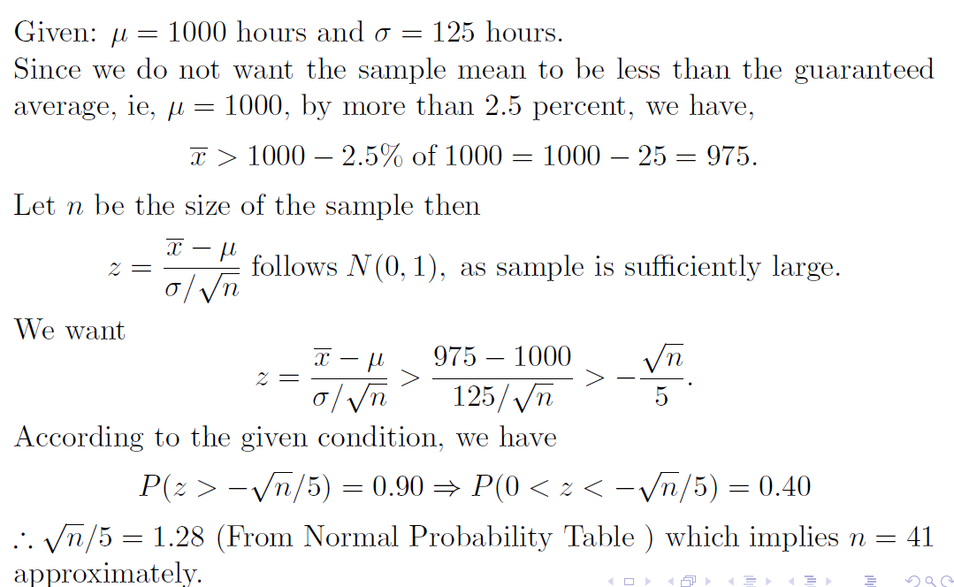



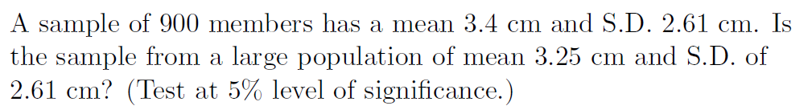



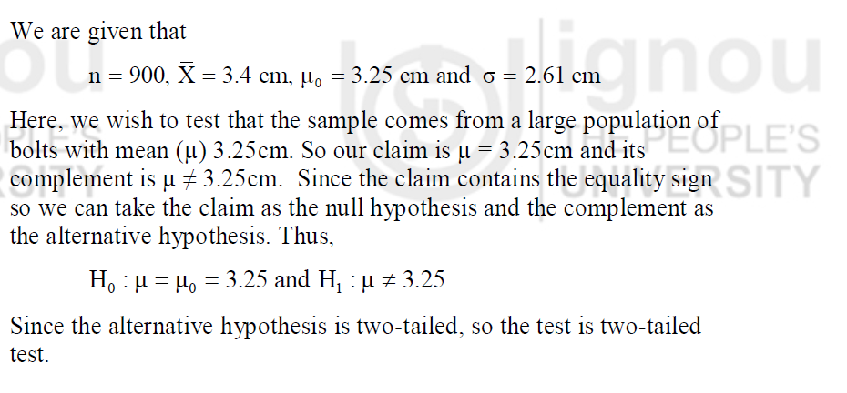  
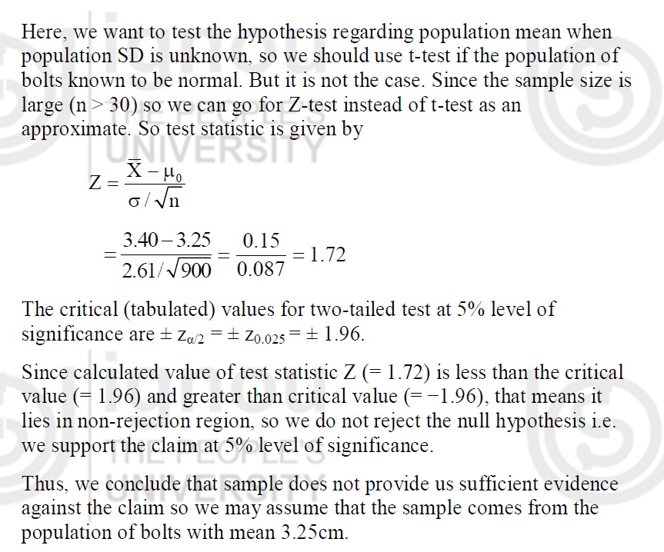





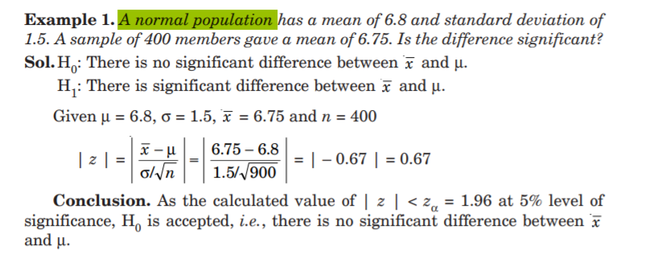

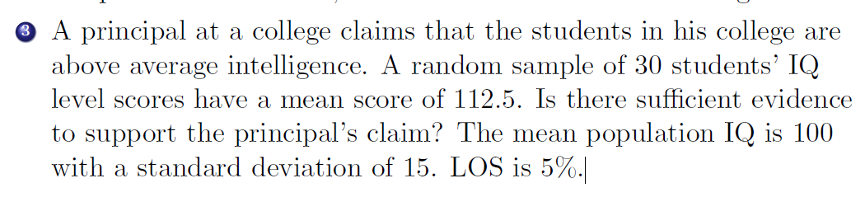  
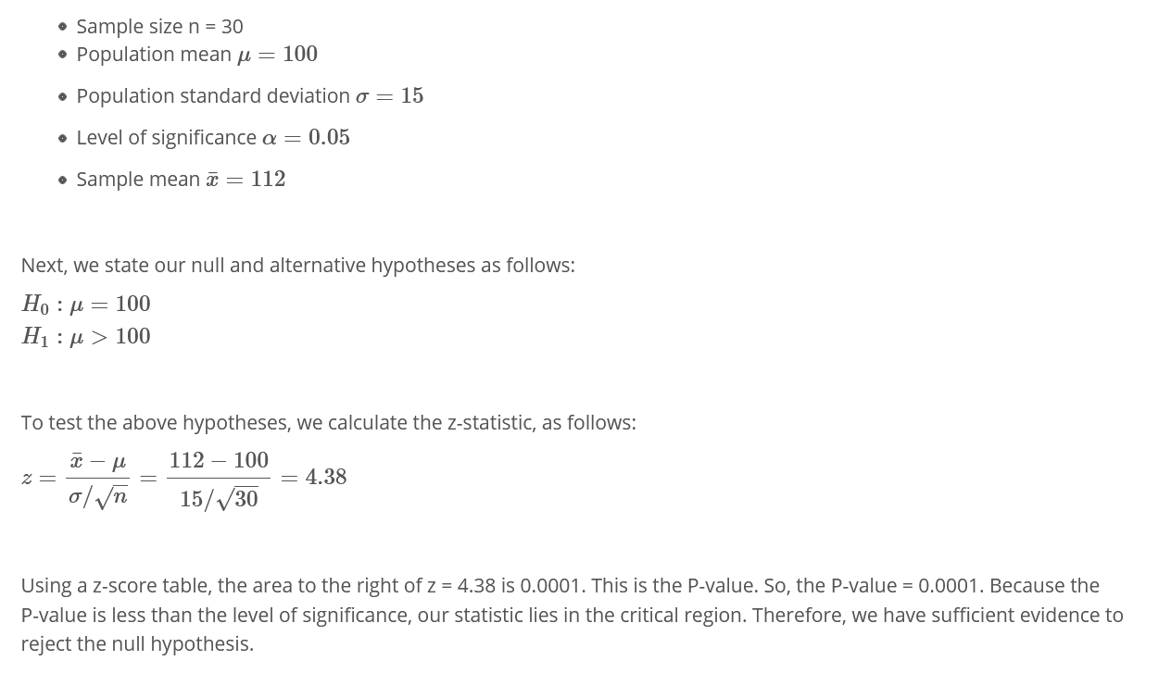



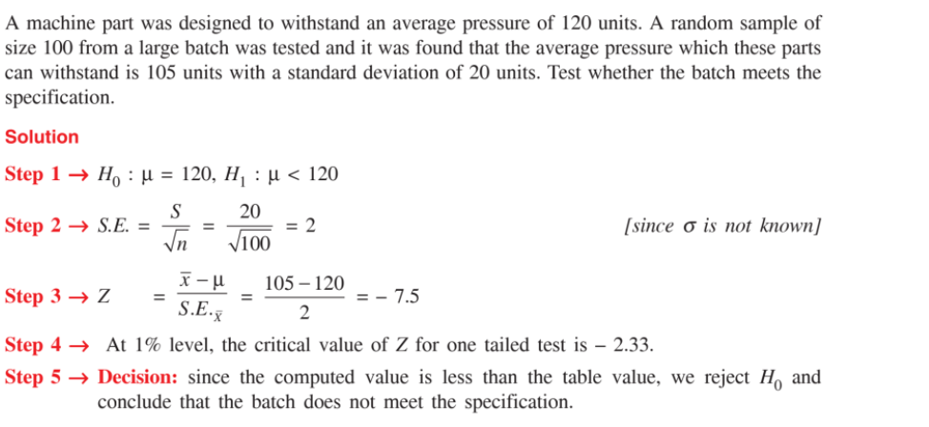



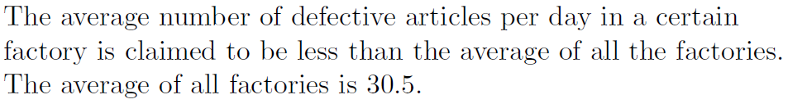  
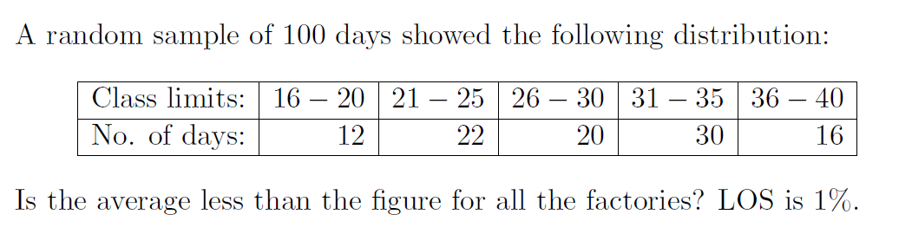



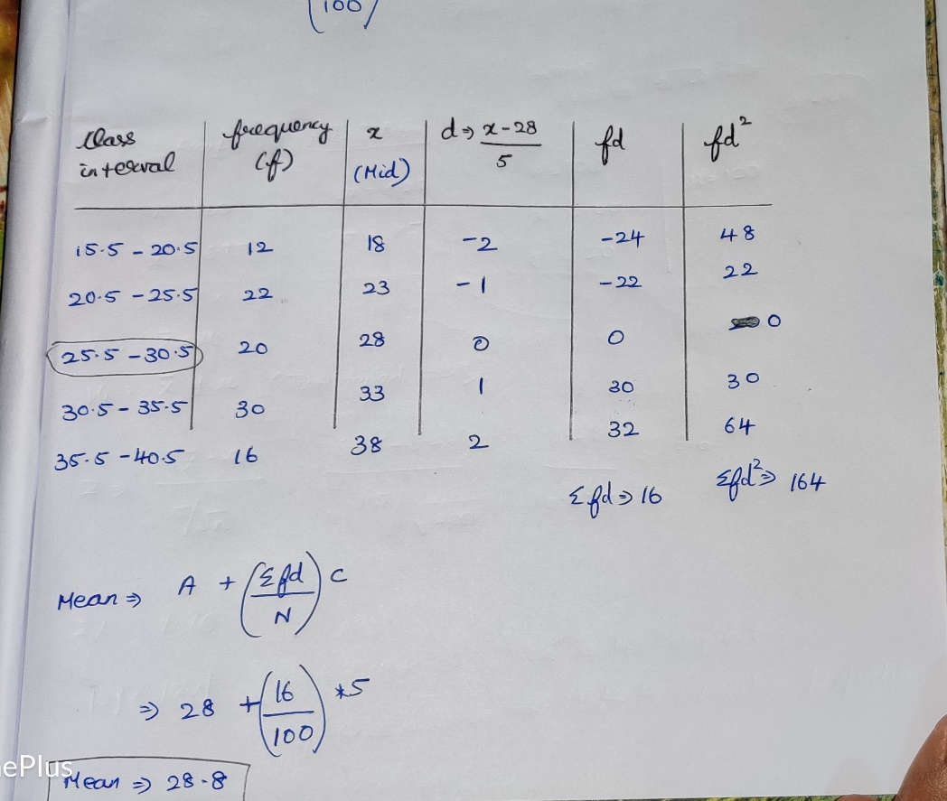

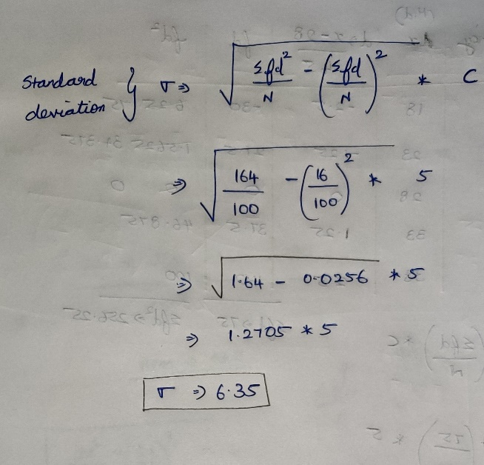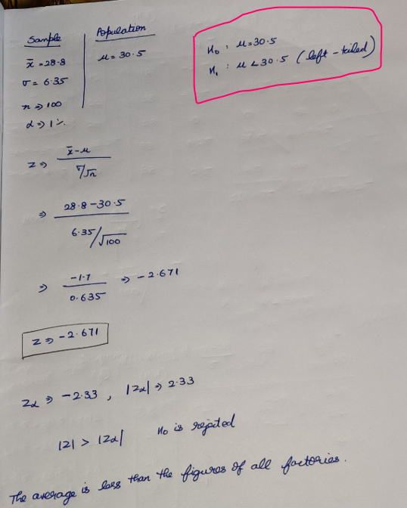



**Case-4  
 Test of significance of the difference between two sample means**

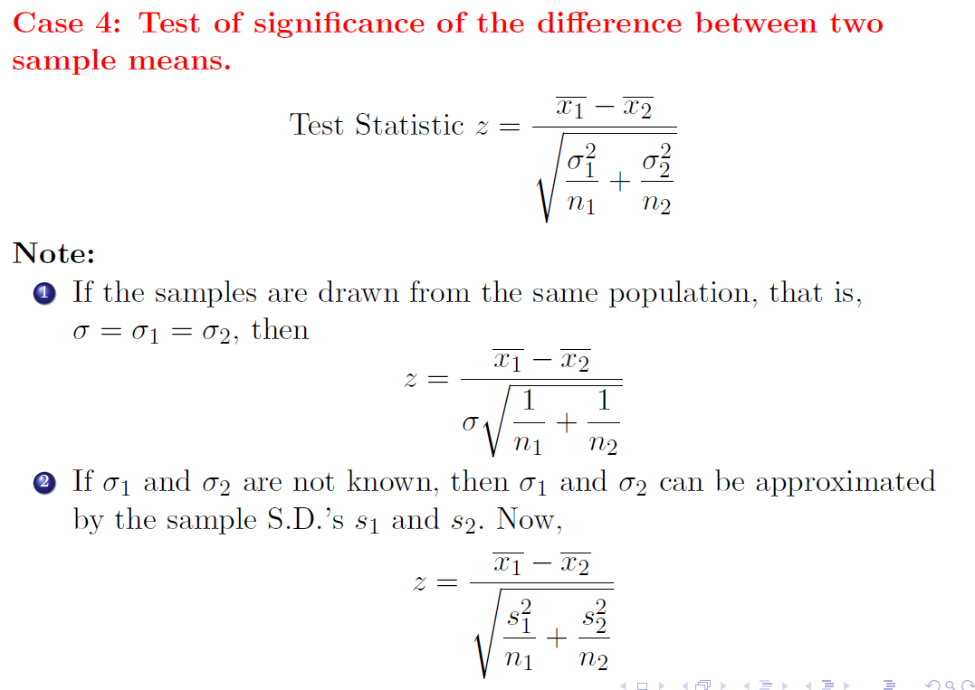

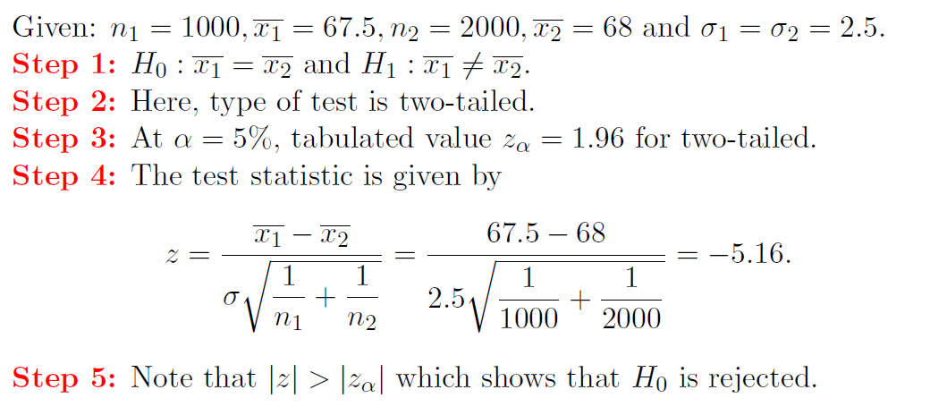

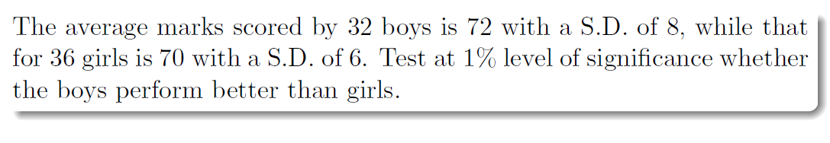  
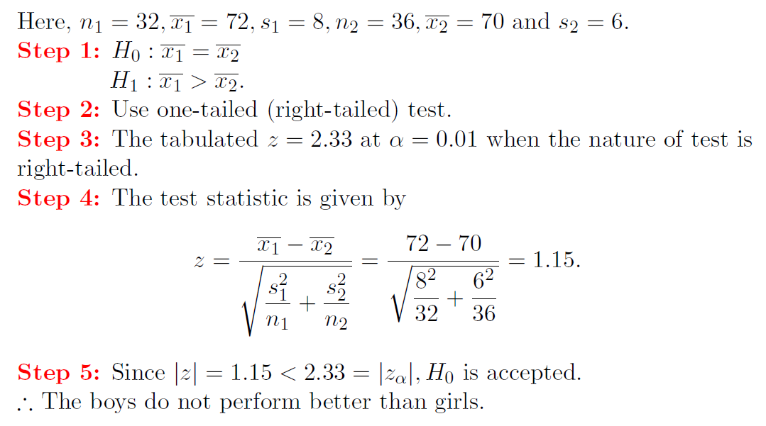

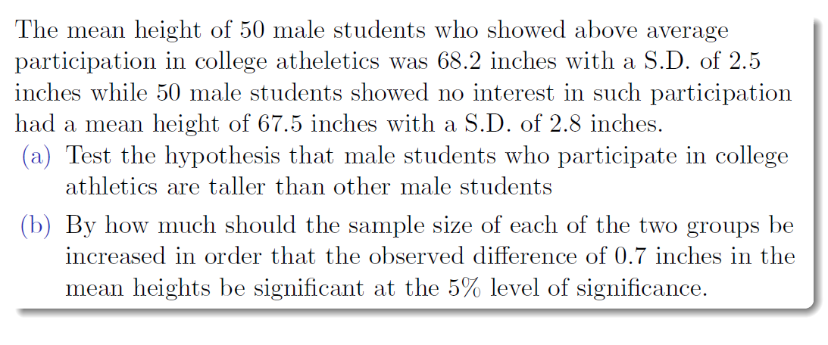

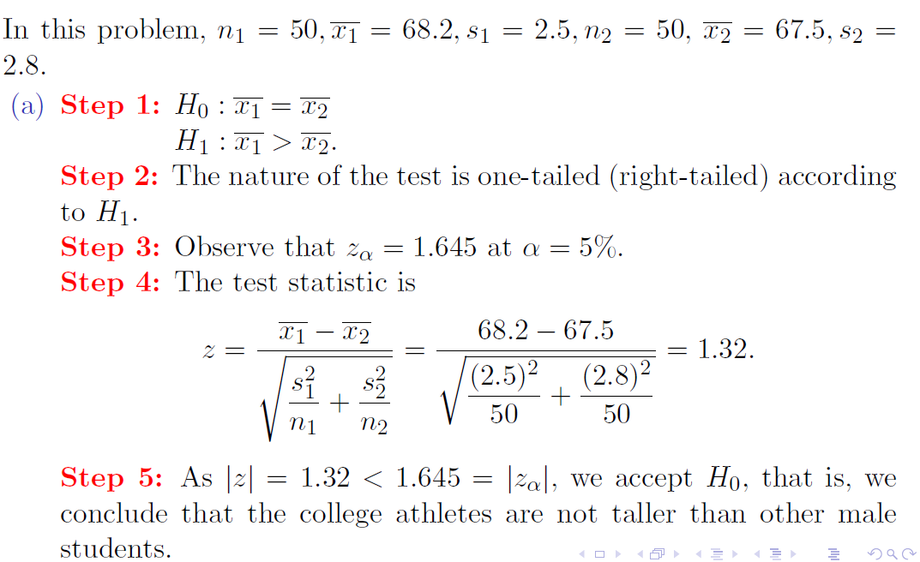

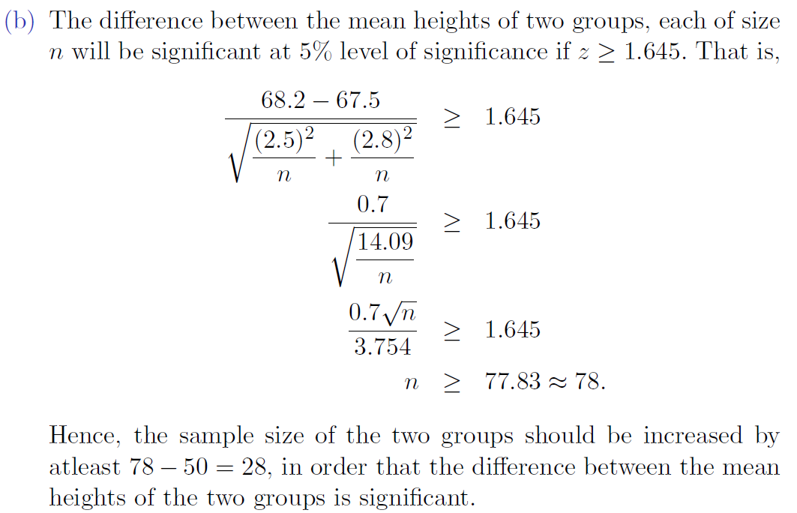

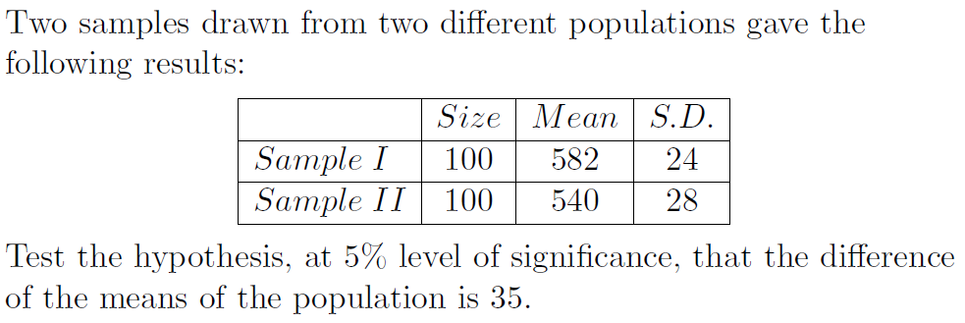

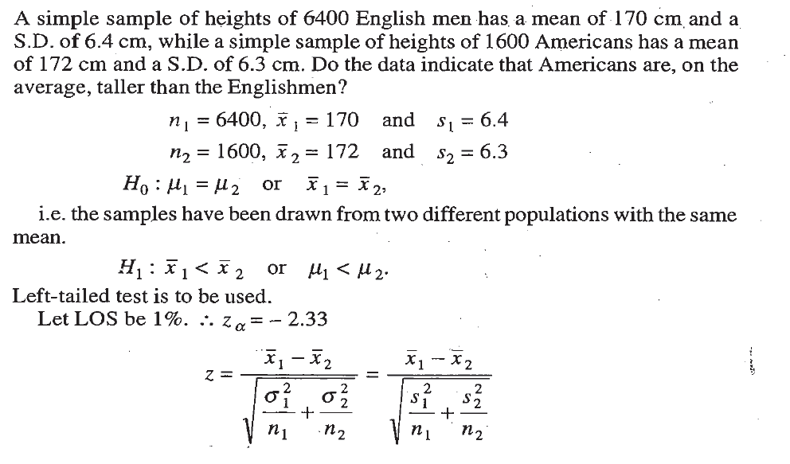  
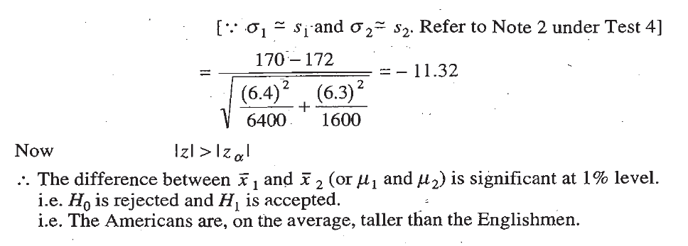

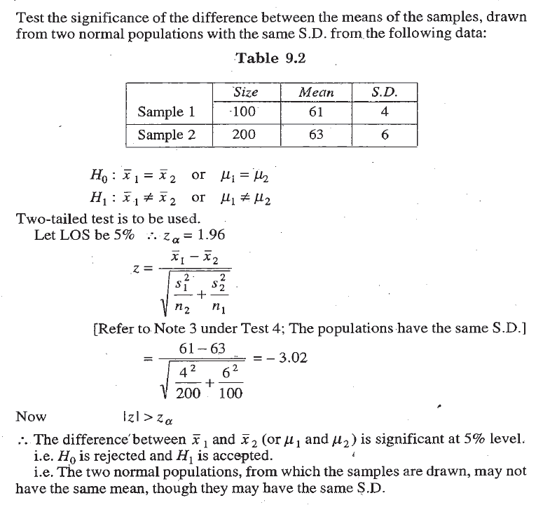

Different concept

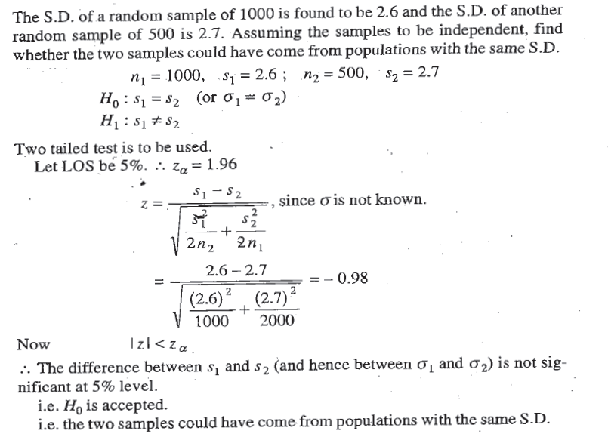

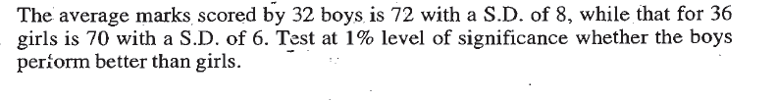  
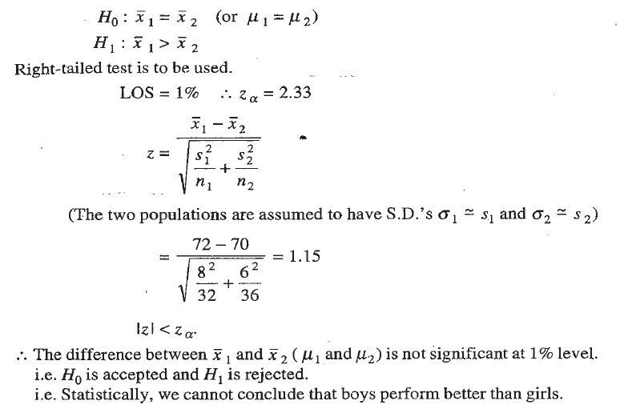

**P-value Method**

